Problem​ ​Statement​ ​1:

Write a Python program using function concept that maps list of words into a list of

integers representing the lengths of the corresponding words.

Hint:​ ​If a list [ ab,cde,erty] is passed on to the python function output should come as

[2,3,4]

Here 2,3 and 4 are the lengths of the words in the list.

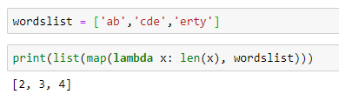

Problem​ ​Statement​ ​2:

Write a Python function which takes a character (i.e. a string of length 1) and returns

True if it is a vowel, False otherwise.

